**Assignment: 7**

**Problem Statement:** Host a website on EC2 service of AWS.

1. Sign in into the AWS account then Go to EC2 click on the instance and click launch instance

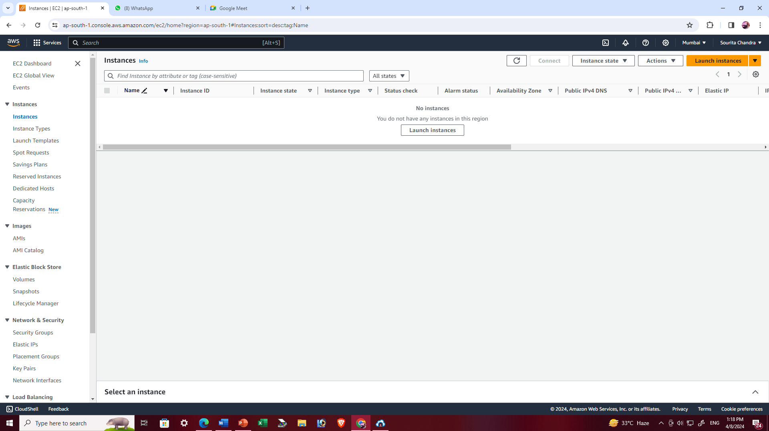

1. On the new window that opens, set a name for the instance, and select the Ubuntu platform.

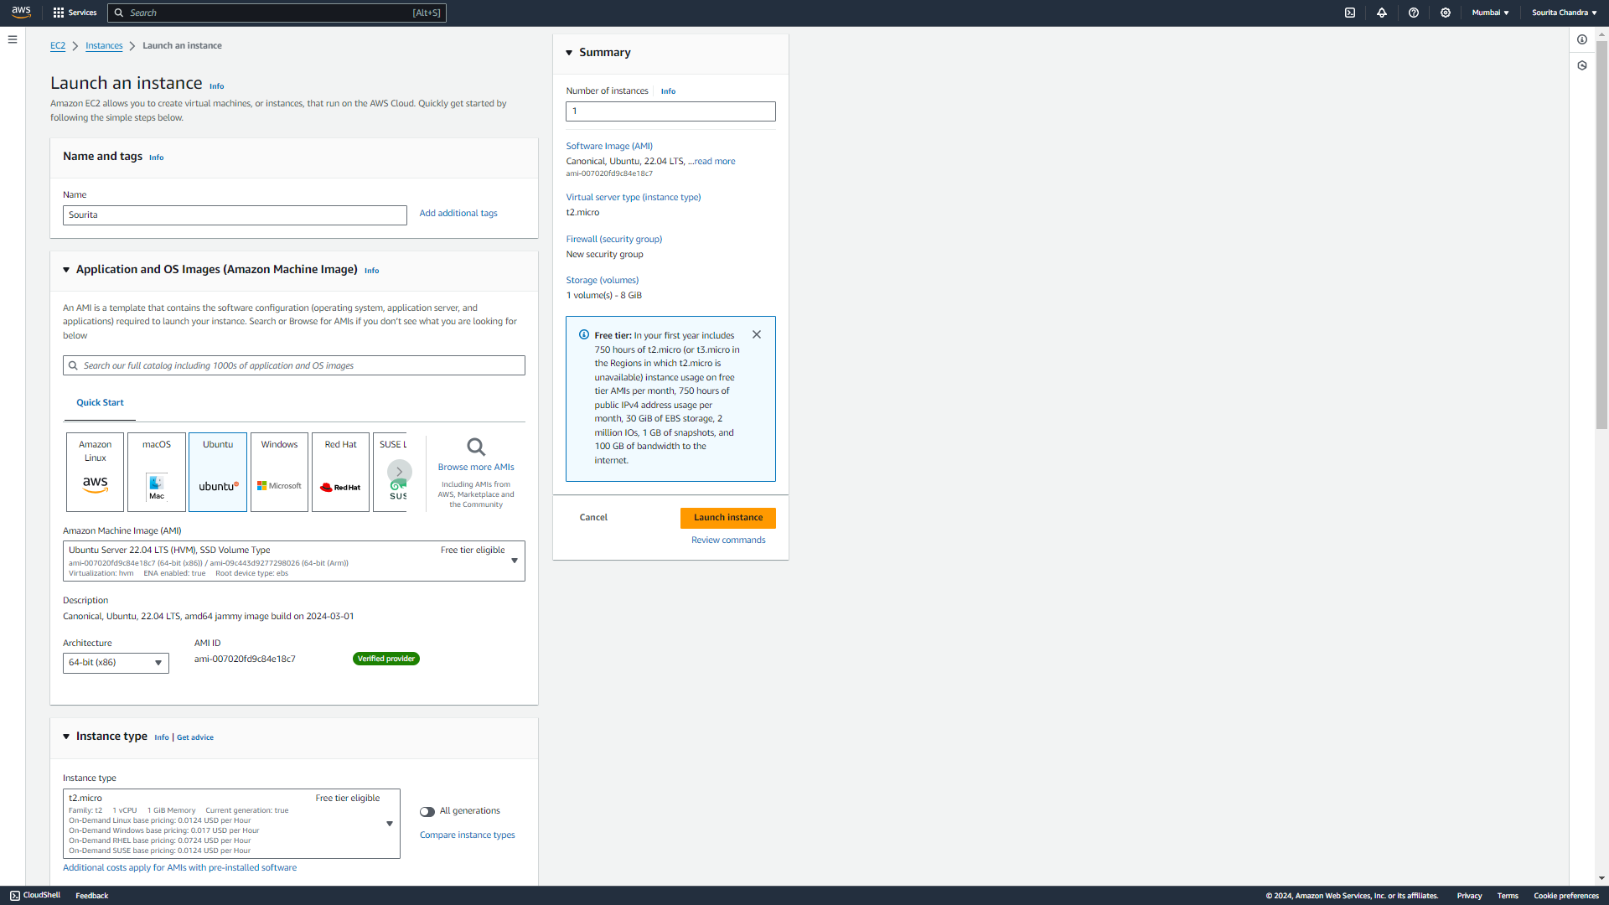

1. Create a new key pair, if does not exist already. For this click on Create new key pair. Then click on the “Create key pair” button. Save the file in some directory on your computer.

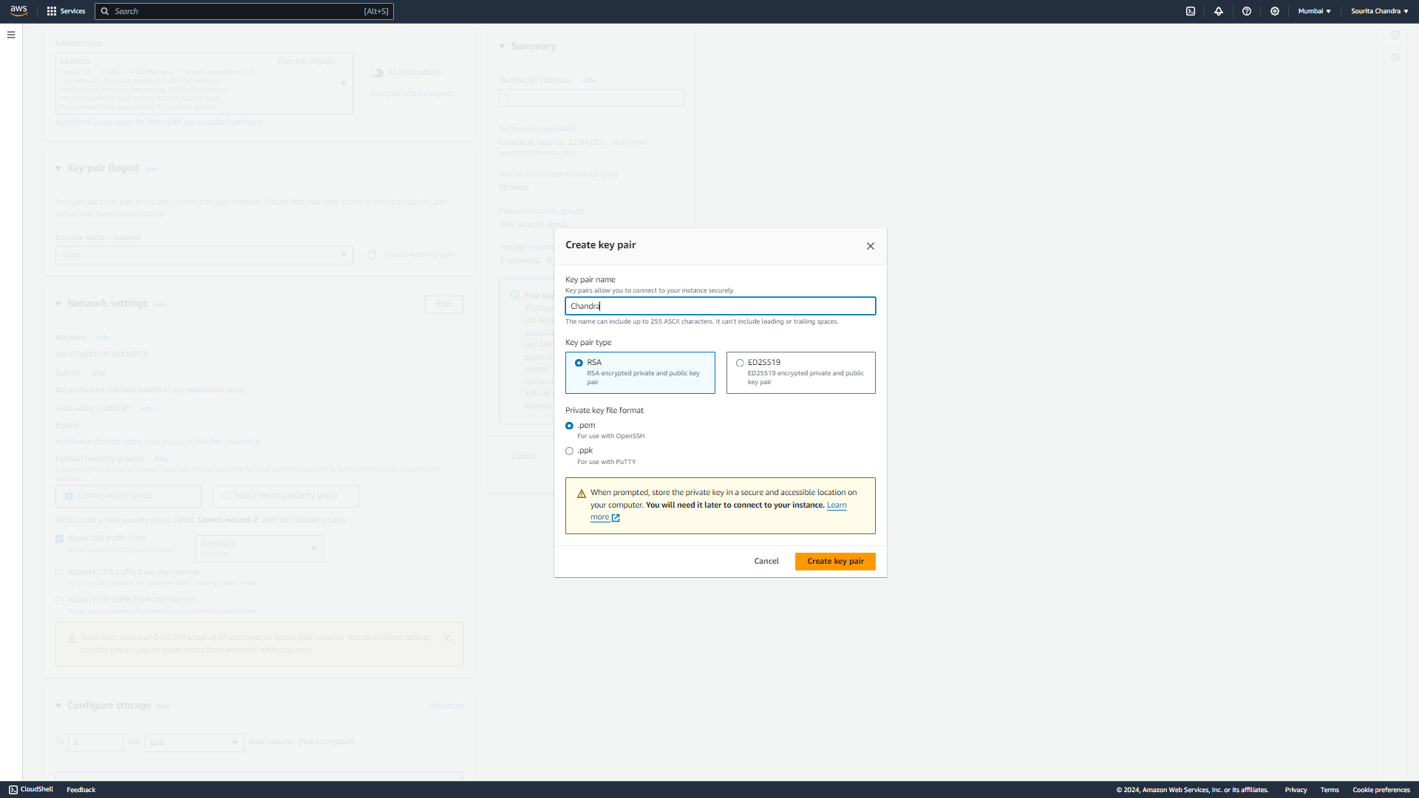

1. Check all the checkboxes, in the firewall settings. Then click on Launch instance. A successful message is shown on a new window. Click on View all instances. After this, a window showing all instances.

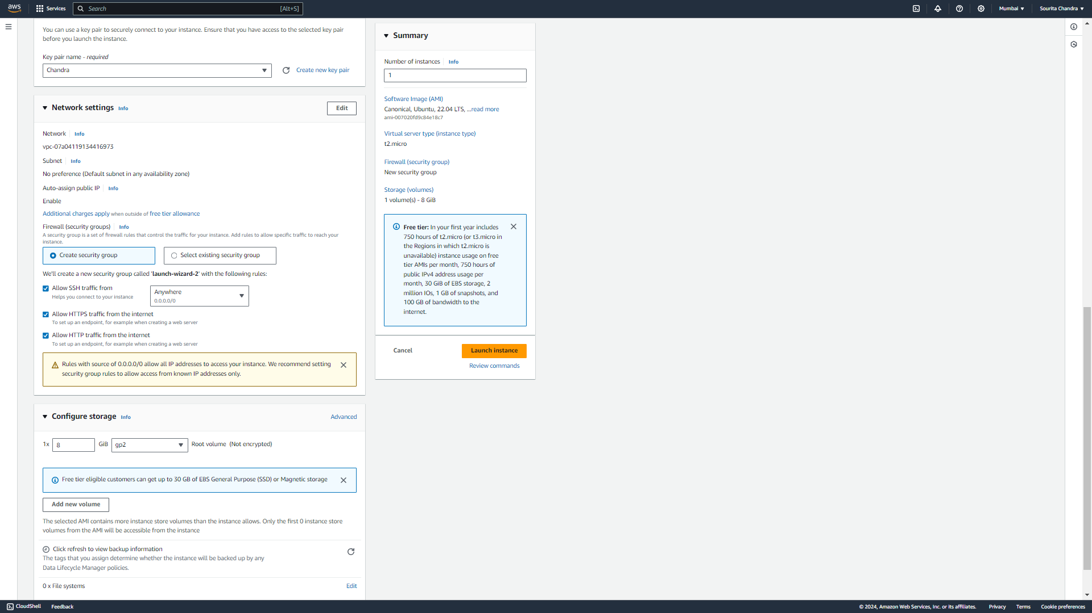

1. Click on the instance ID copy the Public IPv4 address and open bitvise SSH client

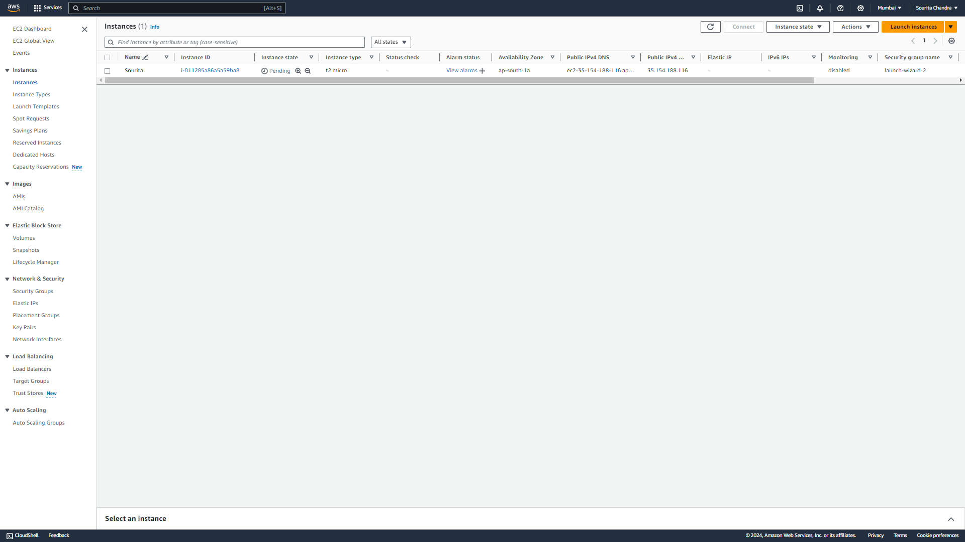

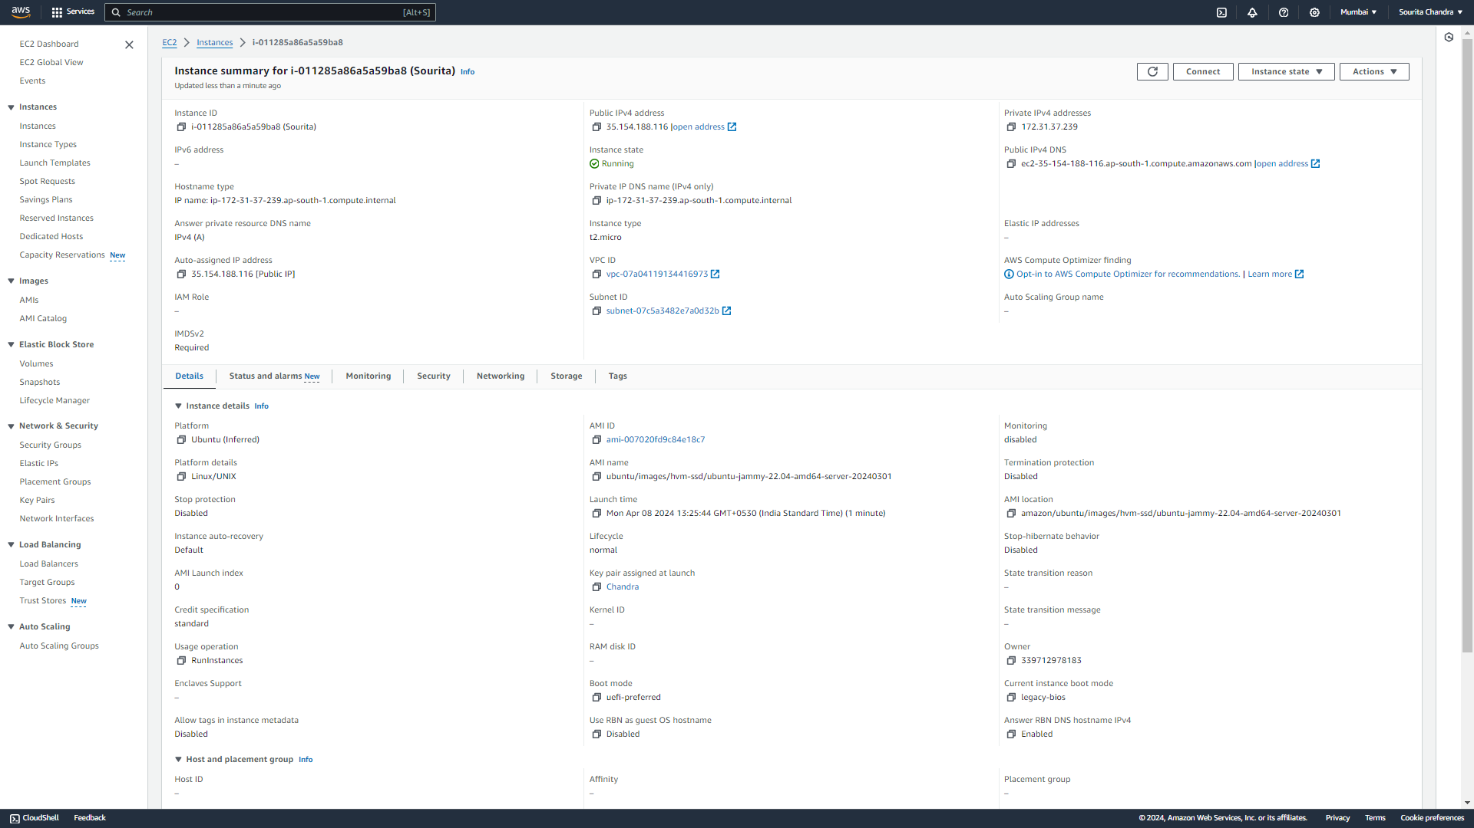

Now, our ec2 service is ready to work.

* **Using Bit vise SSH**

1. If not installed, then go to the website https://www.bitvise.com/ssh-client-download, download the installer, run the installer when downloaded. Now the bitvise client. It is useful for connecting to the server of the ec2 service and install necessary tools to proceed with (however that can also be done directly from the ec2 service website). Moreover, the Bitvise client provides an SFTP client, through which we can transfer files from the local machine to the remote machine, just by simple drag and drop.
2. Open the Bitvise client, and paste the public IPv4 address copied from the EC2 website in the ‘Host’ field.

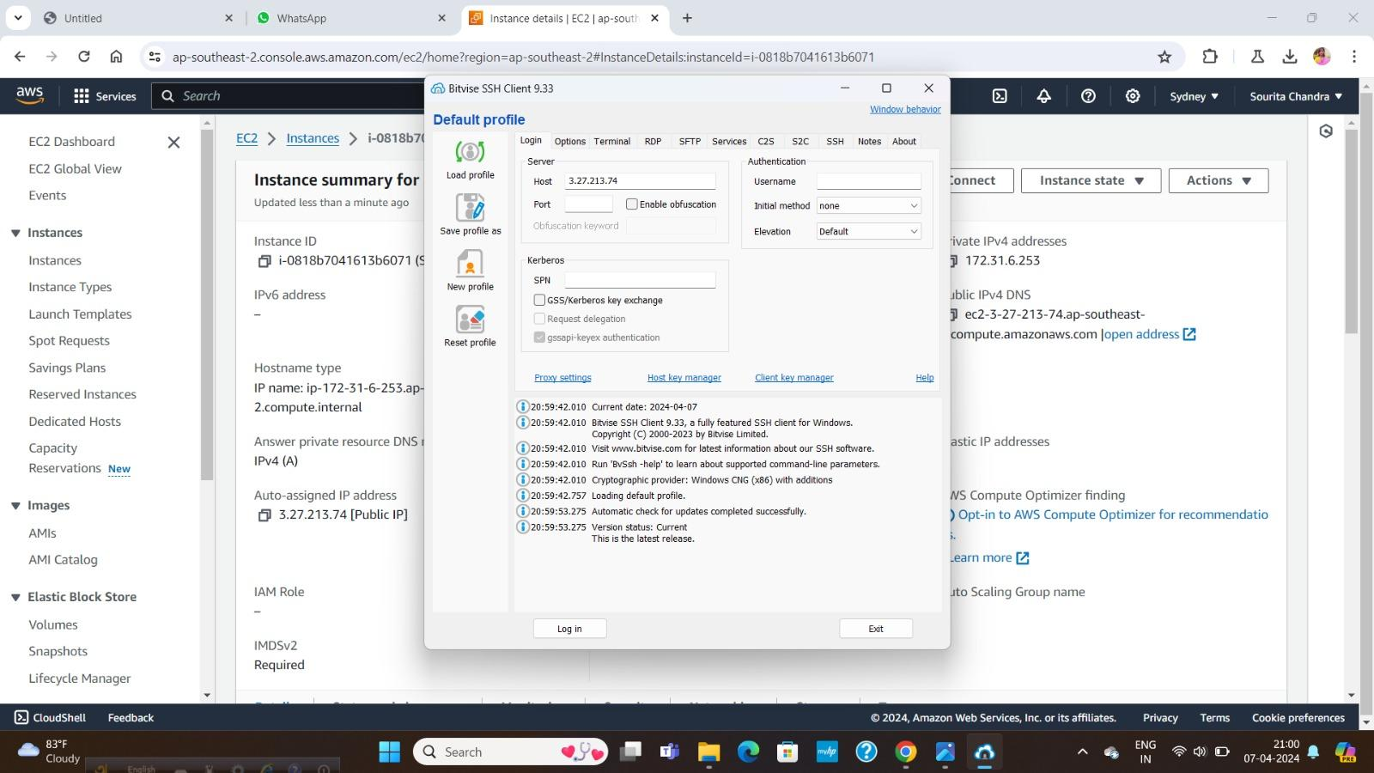

1. Click on the **Client key manager**. Then **Import** button, and using the file picker, select the downloaded .pem file (key pair file). Then leaving all settings default then click on Import. After clicking the key is imported.

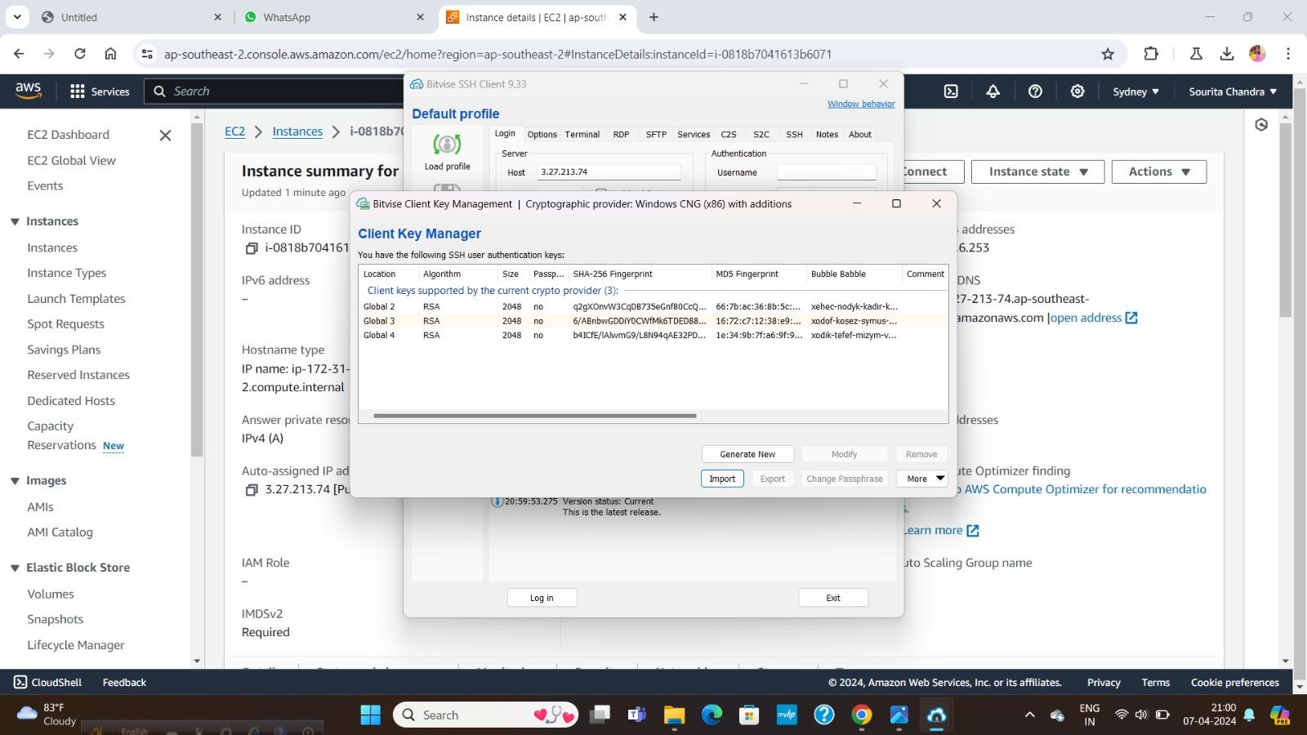

1. Then set username as **ubuntu.**

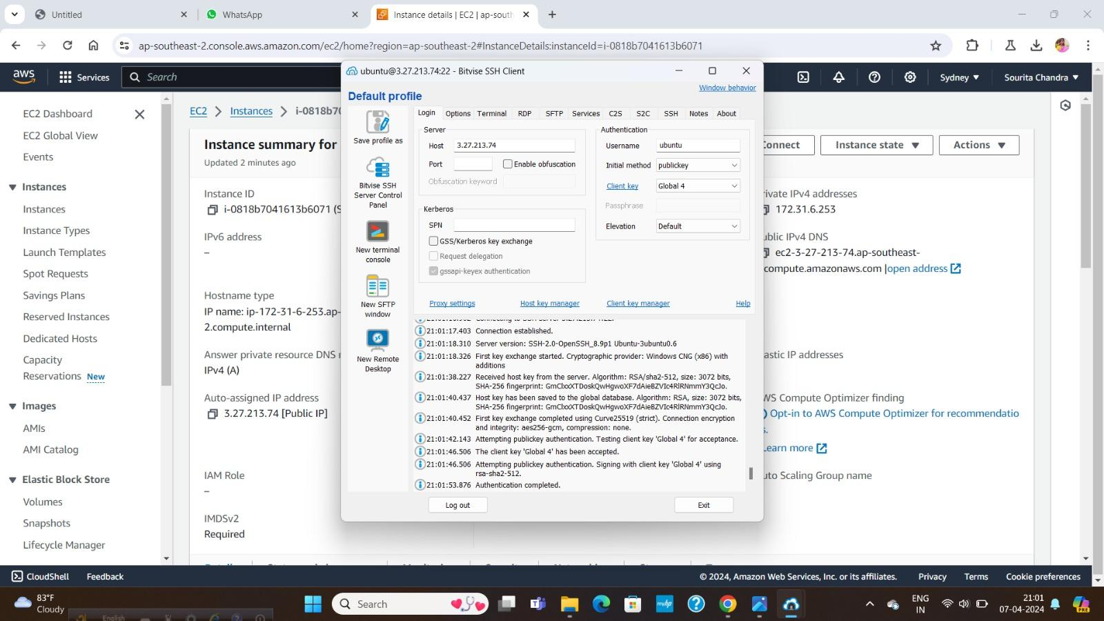

1. Select Client key as **Global 1**.
2. Click on the **Log in** button.
3. Then one pop up is coming click “**Accept and save**” This makes the connection to the server. Now, two new options open in the Bitvise Client “**New terminal Console**” and “**New SFTP window**”

Now Install the nginx server and transferring website files to the remote server

1. In Bitvise Client open the New terminal console. See the current working directory using the **pwd** command. It shows /home/ubuntu. This confirms the connection with the server, and we have open the terminal in the home directory of the serve
2. These commands are to be run on this terminal

* **sudo apt-get update**
* **sudo apt-get upgrade** (Press **y** when asked, and then in the window that opens, select OK and Press ‘Enter’.)
* **sudo apt-get install nginx** (Press **y** when asked, and then in the window that opens, select OK and Press ‘Enter’.)

These will update and upgrade the ubuntu server, and install nginx server on the remote ubuntu machine.

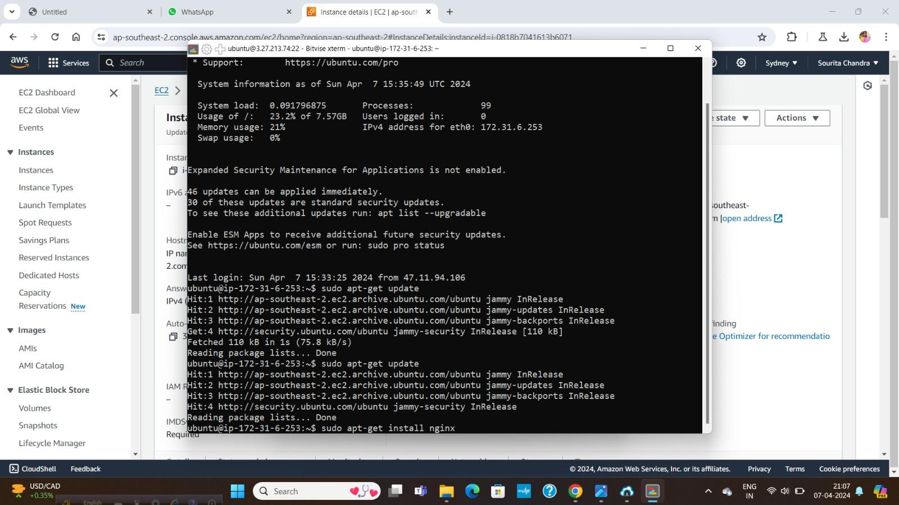

1. Now copy the public IPv4 address and paste it in any browser. It shows ‘Welcome to nginx!’, which confirms the successful installation of nginx on the ec2 remote machine.
2. 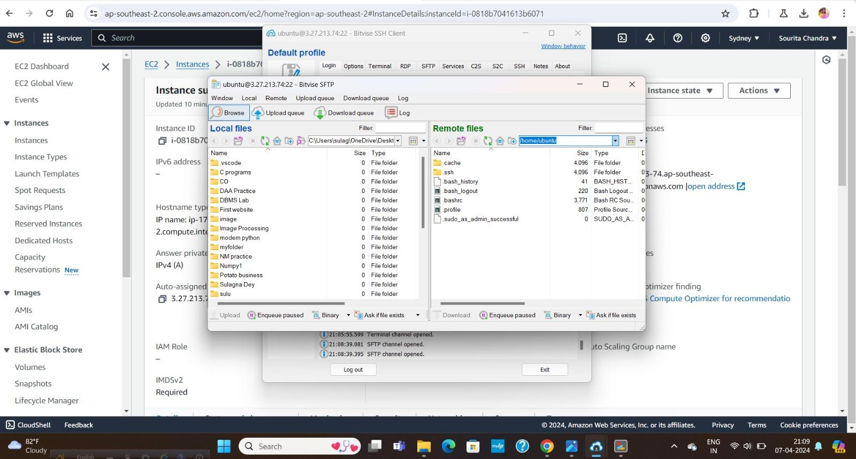Open the Bitvise SSH client window. Open **New SFTP window**
3. In the **Local files section**, open the folder where the static website resides in our computer. (Local files means the files existing on our client machine)
4. Go to the root directory in the **Remote files section**. (Remote files means the files existing in the remote server directory.
5. Then open ‘**var**’ directory. Then inside it, open the ‘**www**’ directory. Then inside it, open the ‘**html**’ directory. This is the directory where we shall keep the html files of our static website, for hosting. We see that the html directory is denying the uploading of files, because it does not have the appropriate permission.
6. To add the permissions, run the following commands in the bit vise terminal console-

**cd /var/www** (for go to the directory to give the permission)

**sudo chmod 777 html** (This gives read, write, and execute permissions for all users, to the html directory)

1. Open SFTP window, and drag and drop the files from the Local files to the Remote files section.

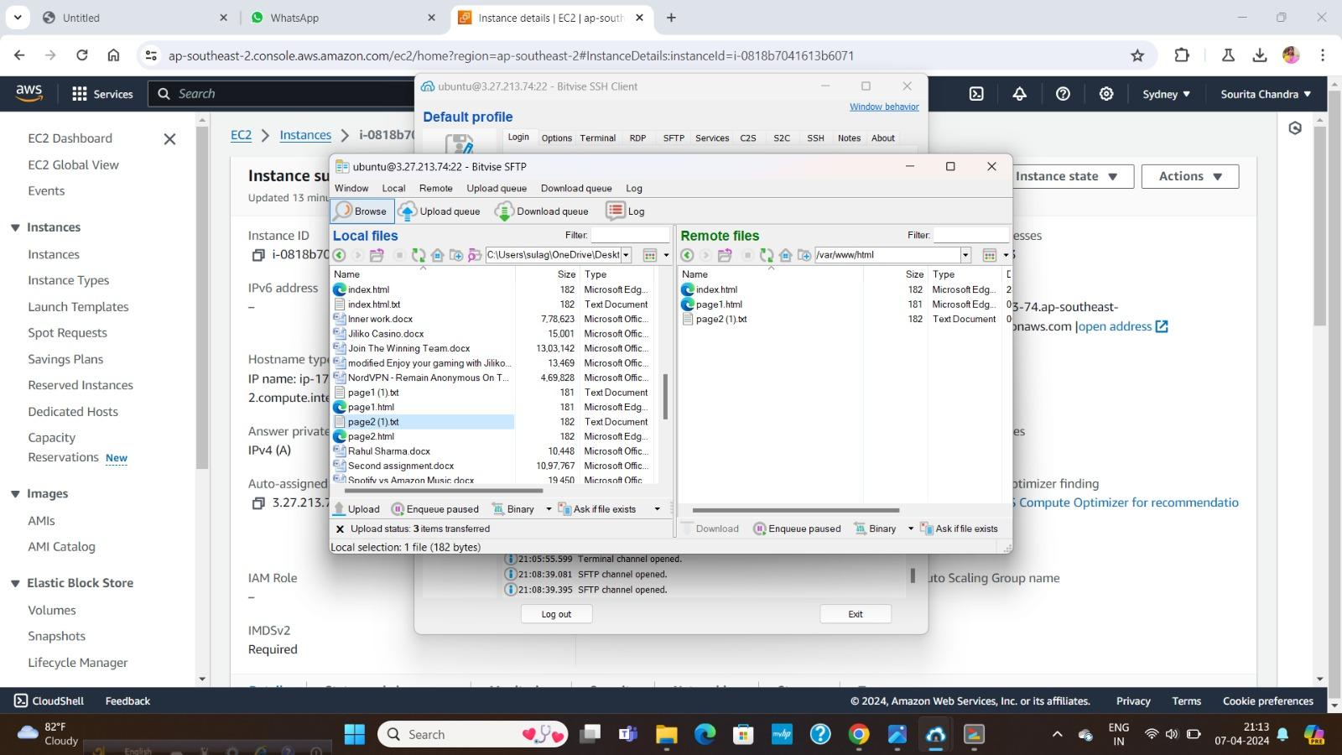

1. Open the public IPv4 address (from the ec2 instance), paste it in web browser. Now our website is visible, through this IP. Finally our website is hosted on the EC2 service.

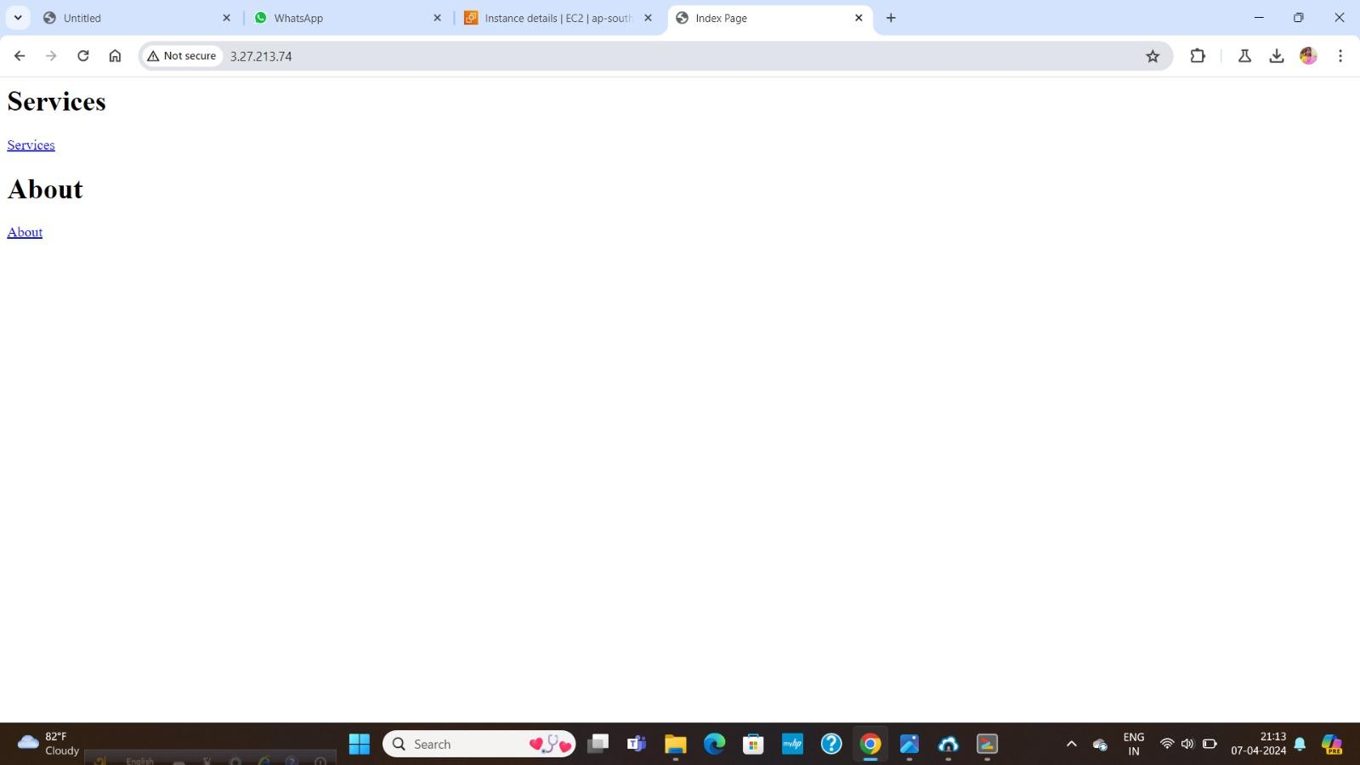

1. Now close the SFTP window, and the terminal console.
2. Log out of the remote server, from the Bitvise Client.

Then close the Bitvise Client.

1. We know that AWS services are not free forever. They have a limited time free-tier, after which there are charges to be imposed. So, if we want to keep this website alive, we need to pay for the server. Since, this is for testing purpose, we will just terminate this Instance.
2. For terminate it Select the Instance from the AWS
3. Click on instance then “**Instance State**” then “**terminate instance**”
4. One pop up is given click “Terminate”. After some time we see that the instance is automatically delete and we can’t access the server using that IPv4 address.



